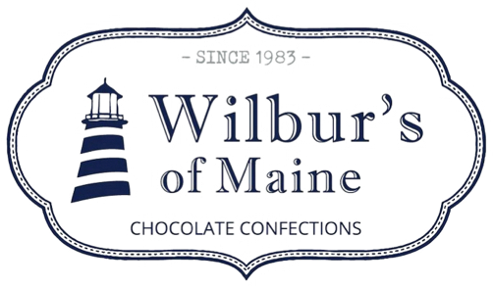
Enrobing Packaging Assistant
Reports to: Enrobing Packaging Supervisor
Job Overview: Packaging Assistant will be responsible for packing various sweets and chocolate confections for distribution and sale.
This is a full or part time position. Sometimes limited hours are available depending on business demand. Seasonally and at holidays, employees are expected to work additional hours. Overtime hours are only considered approved if advanced written approval from the Production Supervisor (interim A. Wilbur) is obtained.
Essential Responsibilities and Duties:
- Work closely with Packaging Supervisor to identify daily packaging requirements
- Become proficient with all packaging stations and bagging requirements
- Identify and pack only first quality products
- Pull and return product/packaging to proper storage areas with 100% accuracy
- Pack products in various bags, pouches, and boxes.
- Identify & verify correct dates, labels and ingredients for products
- Perform clean-up activities as assigned
- Ability to work as part of a team, can accept coaching and feedback from supervisor and others
- Be a Team Player, Good communication and interpersonal skills
- Basic math and literacy skills
- Physical dexterity
- Available for shift work and weekends as needed
Qualifications
- High School Diploma or GED
- Attention to detail a must
Physical demands
While performing the duties of this job, the employee is regularly required to stand, stoop, kneel, crouch, sit, walk, reach with arms and hands, talk and hear. They will regularly lift and/or move objects 10-25 pounds, and occasionally lift and/or move objects that weigh more than 50 lbs. They may occasionally be required to climb and balance. While performing this position you will be required to stand on hard surfaces for the duration of your shift. They must have hand dexterity and be able to hand tie ribbons and bows.

Work Environment
The noise level in the work environment can be loud to moderate depending on the packaging area. You must be able to work in various degrees of temperature. Fast paced. Chocolate sampling is encouraged

